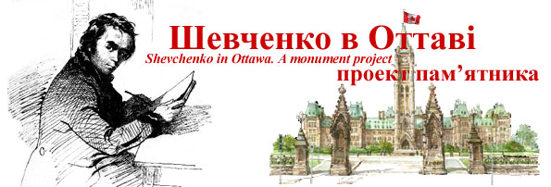

Ottawa Shevchenko Monument Committee Meeting
Thursday, January 27, 7pm, St. John National Shrine.
Agenda:
* Construction progress – Architect Derek Crain
* Fundraising strategy and logistics:
• Special Events and Activities (presentations, kiosks, interviews, plaques on donation walls, silent art auction, embedding Kaniv soil from Taras’s grave into the base of the monument, ground-breaking ceremony, etc.)
• Special National Information/Donation flyer mail-outs (media blitzes, bulletins – UCC National and Ottawa, Churches, Credit Unions, UCPBA/UCPBF, Chamber of Commerce, Buduchnist, etc.)
• Special Local Community mail-outs and presentations (UCC, UCPBA, churches, etc.)
• Plan for Contacting Major Donors (Foundations, Ukrainian philanthropists/community/business leaders, Ukrainian MPs, etc.)

Notes:
- A meeting is scheduled to take place in February with all Ukrainian organizations, at Fr. Okhrimchuk’s initiative, to organize a Ukrainian Festival in Ottawa, so our meeting is timely and can create some related ideas for an unveiling.
- 2011 is the 120th Anniversary of Ukrainians in Canada and the 150th Anniversary of the death of Taras Shevchenko. 2011 is also the 20th Anniversary of Ukraine’s Independence.

Orest Dubas
Chair

