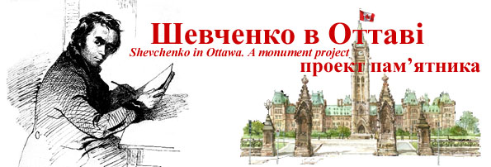

Meeting - Ottawa Shevchenko Monument Committee
Thursday, March 27, 2008, Ukrainian Catholic Shrine, 952 Green Valley Crescent

Agenda

Update  - Shevchenko Art Auction in Ukraine – 400,000 hryvnia?  - President Yushchenko Visit – tentatively May 25, 2008  - Donor Letters – Buduchnist, SUM, UCC National, Melnyk, Kule, CUCC, Bill Teron, Danyliw Foundation, Huculak, Temertey, St. Michaels  - Advertising – Homin, Novy Shliakh color inserts  - Letters - Mrs. Mol, Thank you letters/Certificates to Donors | Orest Dubas  Olena Zakharova  Bohdan Malyna
Next Steps / Action Items / Challenges

Presidential Visit – Program | Olena Zakharova  Orest Dubas
Advertising – MEEST, Ukrainian News, etc. | Bohdan Malyna
Monument Erection  - Site visit - next week – Radoslav Zuk, Derek Crain, with Fr. Cyril Mykytiuk – finalization of monument composition and site design | Ron Sorobey  Orest Dubas
- Site preparation, Landfill, landscaping – Maurice Dulepko | Bohdan Malyna
Fundraising Campaign  - Followups with donors who did not respond  - New Donors – Semchuk – Windsor, Prosvita in Montreal?  - Application letters to Foundations – Buduchnist BCU, Taras Shevchenko | Orest Dubas  TBD
Legal  - Charter – update of Draft prepared by OD  - MOU with Catholic Shrine – update of Draft prepared by Ron – between Shrine and Committee  - Responses to Donor questions/issues – Semchuk, Makohon – Ownership, access rights, long-term maintenance – Fund, Committee? | Ron Tomosk  Lubomyr Chabursky  Orest Dubas
Finances  - Budget and Expenses, Status Reports | Mark Shwed, Nadia Dubik
Web site  - Updates to Donor pages and Financial Information | Franck Lalande  Gerry Kokodyniak
Videos from Stan Klosevych – Edit and send to KONTAKT | Orest Dubas
Ottawa Events – Trade Show – April 13 – Need members to join | Orest Dubas
Committee members – Call members and update their status; post on Web | Ron Sorobey  Bohdan Malyna
Next Meetings –Dates?
- Committee
- Community
Orest Dubas, Chair

