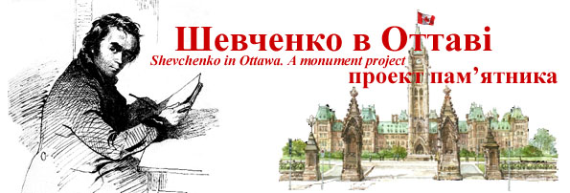

Meeting - Ottawa Shevchenko Monument Committee
Thursday, May 8, 2008, 7:00pm, Ukrainian Catholic Shrine, 952 Green Valley Crescent

Agenda

News  - New Donation being received – $100,000  - President Yushchenko Visit – 25, 2008 | Orest Dubas  Olena Zakharova
Action Items / Challenges

Presidential Visit – Program – May 25, 2008  - Official program  - Issues: Choirs, Schools, etc.  - Poster on stand – 4ft x 8x | Olena Zakharova  Bohdan Malyna  Orest Dubas
Advertising – Articles in Newspapers, etc. | Bohdan Malyna
Legal – MOU with Catholic Shrine  - Agreement on Draft prepared by Ron/Orest – between Shrine and Committee  - Responses to Donor questions/issues – Semchuk, – Ownership, access rights, long-term maintenance – Fund, Committee | Ron Tomosk  Lubomyr Chabursky  Orest Dubas
Monument Erection  - Site visit - Radoslav Zuk, Derek Crain, Fr. Cyril Mykytiuk – finalization of monument composition and site design  - Discussions with NCC – May 20 | Orest Dubas
Fundraising Campaign - Finances  - Status report - Donations received to-date: $33,219.  - Awaiting formal cheque from new Donors – Bob Semchuk – Windsor Prosvita - $100,000  - Application letters to Foundations – Buduchnist BCU, Taras Shevchenko | Mark Shwed  Orest Dubas  TBD
Web site  - Updates to Donor pages and Financial Information | TBD
Videos from Stan Klosevych – Edited and sent to KONTAKT | Orest Dubas
Ottawa Events – Trade Show – April 13 | Orest Dubas
Next Meetings –Dates?
- Committee
- Community
Orest Dubas, Chair

